Creates a foreground mask of moving objects for each frame

Create and use a background model, the static part of the scene

Consists of background initialization and background update

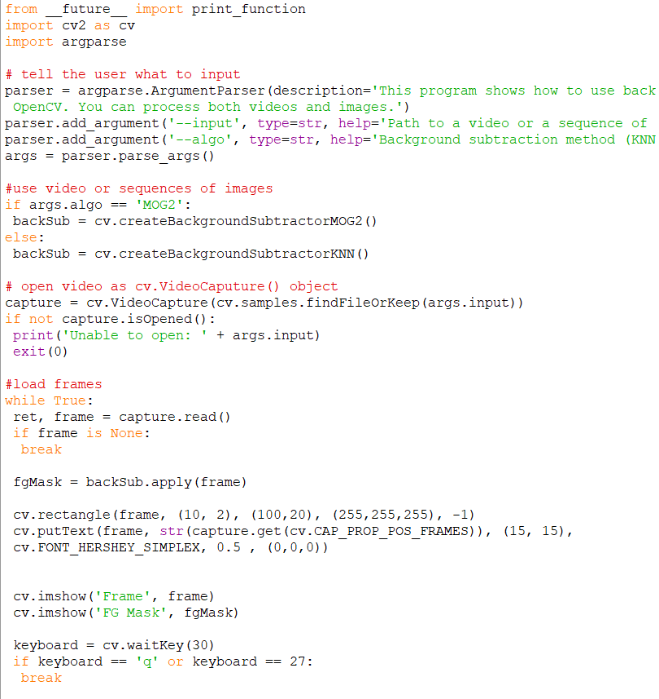

Results using a stock video with a somewhat static background

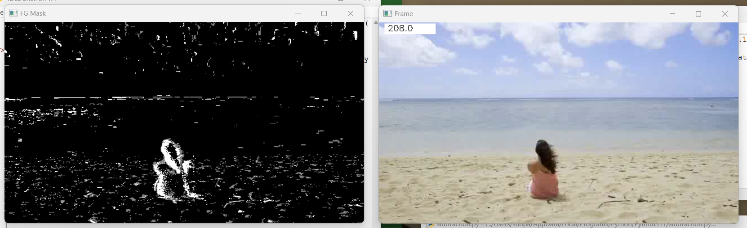

First a background subtractor is created to use either [**createBackgroundSubtractorKNN**](https://docs.opencv.org/3.4/de/de1/group__video__motion.html#gac9be925771f805b6fdb614ec2292006d) or [**createBackgroundSubtractorMOG2**](https://docs.opencv.org/3.4/de/de1/group__video__motion.html#ga2beb2dee7a073809ccec60f145b6b29c) to create the foreground mask. KNN uses k nearest neighbor to create background model, MOG2 uses a gaussian mixture bases background foreground segmentation

VideoCapture object is created to read video file

Every frame is loaded with the while loop

Then the background subtractor is applied to the frame

Current frame number is accessed from videocapture object and frame and mask are displayed